**Predicting promising locations for opening a bakery in Toronto**

Amy Jursz

December 18,2020

1. **Introduction/Business Problem**
   1. **Background**

According to a 2019 study from Ryerson University, Toronto was the second fastest growing Metropolitan Area and the top growing city in all of the United States and Canada. The population of Toronto increased by 77,435 persons, far out pacing the next city – Phoenix with 25,288.

* 1. **Business Problem**

With this large influx of people, more business will be required to support them including gyms, retail stores, restaurants, etc. One of the main questions, and one of the main reasons for success, regarding opening a business is - as they say “location, location, location”.

In this exercise, we will analyze current venue locations in Toronto to determine possible new locations for opening a Bakery.

1. **Data**

**2.1 Data Sources**

1. Wikipedia.org:

This will be used to obtain postal codes of Toronto, Canada which will be used in conjunction with Concl.us data to map the greater Toronto area.

Example:

| **Postal Code** | **Borough** | **Neighborhood** |
| --- | --- | --- |
| M1S | Scarborough | Agincourt |
| M8W | Etobicoke | Alderwood, Long Branch |

1. Cocl.us:

Contains longitude and latitude of Toronto, Canada postal codes which will be used in conjunction with Wikipedia data to map the greater Toronto area.

Example:

|  |  |  |
| --- | --- | --- |
| Postal Code | Latitude | Longitude |
| M1B | 43.80669 | -79.1944 |
| M1C | 43.78454 | -79.1605 |

1. Foursquare.com:

This website contains business data for a multitude of businesses worldwide. This data includes location, business category and can include ratings and reviews of businesses. We will use this website to identify current bakery locations.

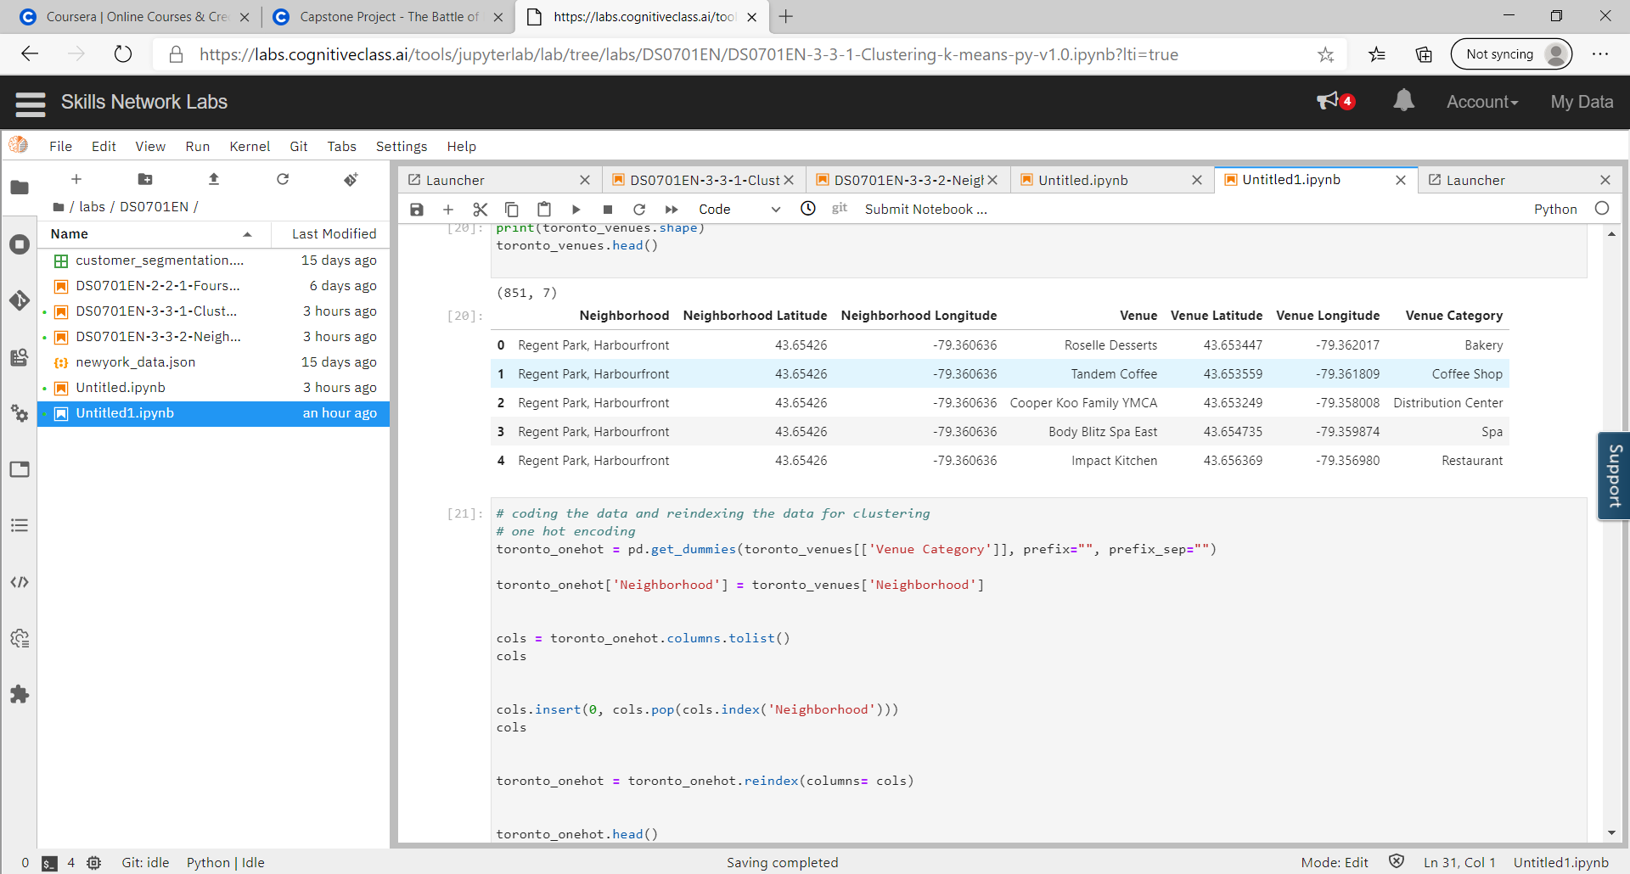

1. Ryerson.ca:

Contains growth data regarding Toronto, Canada referenced in the introduction. Full link provided:

<https://www.ryerson.ca/cur/Blog/blogentry35/>

**2.2 Data cleaning**

Data downloaded from Wikipedia contained many postal codes that were not assigned a borough or neighborhood. These data points were scrubbed from the dataset. Then the updated dataset from Wikipedia was combined with the dataset from Cocl.us to form a new dataset. This new dataset encompassed all location data, postal codes, boroughs, and neighborhoods of the greater Toronto area.

1. **Methodology**

**3.1 Data analysis**

After downloading and cleaning the data from Wikipedia and Conc.us, we need to locate the latitude and longitude for Toronto. This was done with geopy geolocator.

Next was using the appropriate latitude and longitude to get venue data using the Foursquare API. All venues within 500 metes from the designated latitude and longitude were pulled. The information on the venues pulled included:

* Neighborhood
* Neighborhood Latitude
* Neighborhood Longitude
* Venue
* Venue Latitude
* Venue Longitude
* Venue Category

A new data frame was created with the above information – containing 851 rows and 7 columns. Below is a sample of the list:

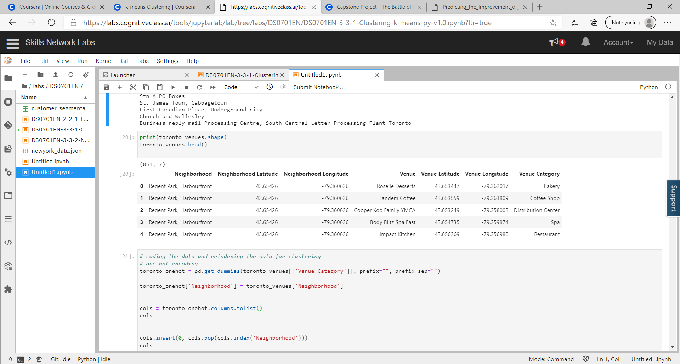

The next step was to convert the data into categories and reindex it using one hot encoding. 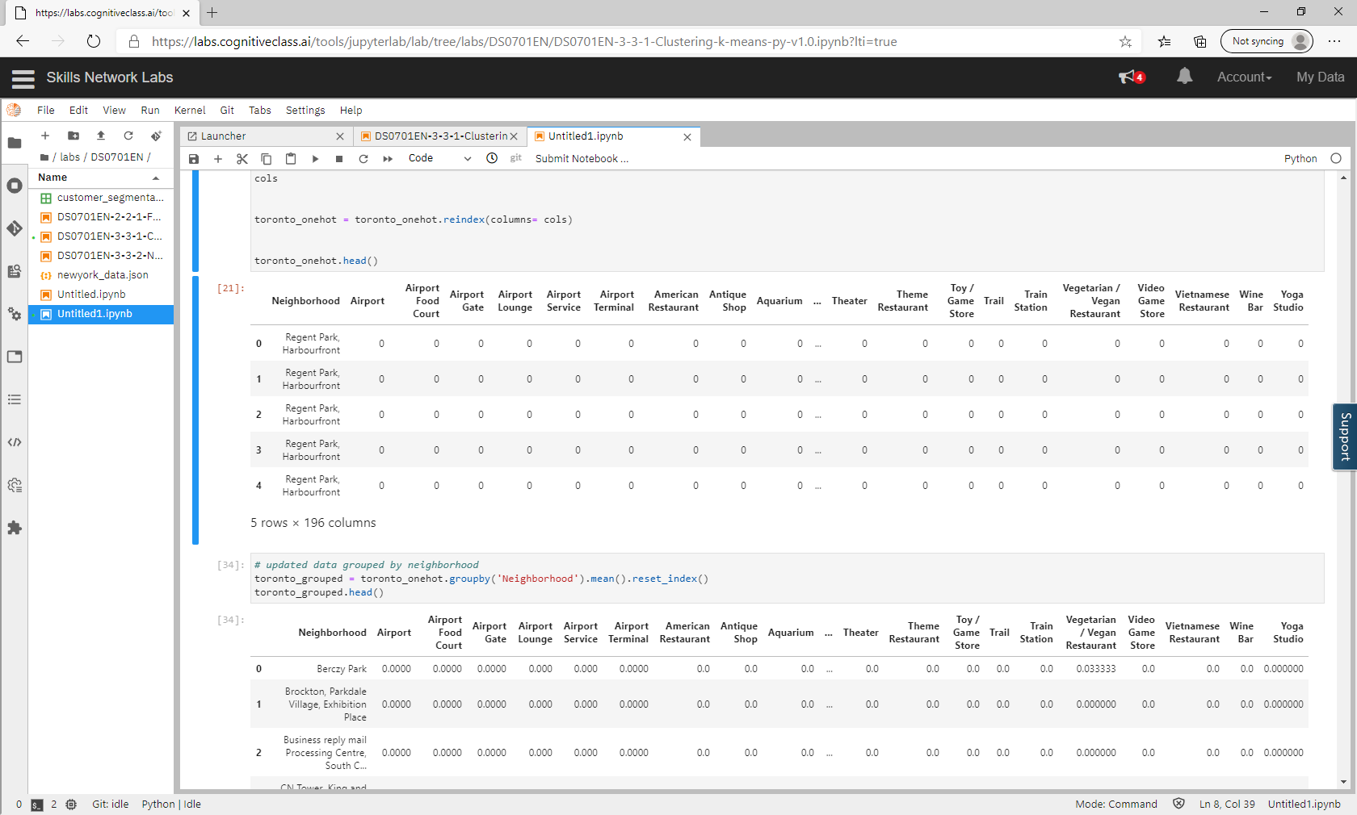

Then the data was grouped by neighborhood and the average occurance (mean) was calculated for each venue category for that neighborhood. 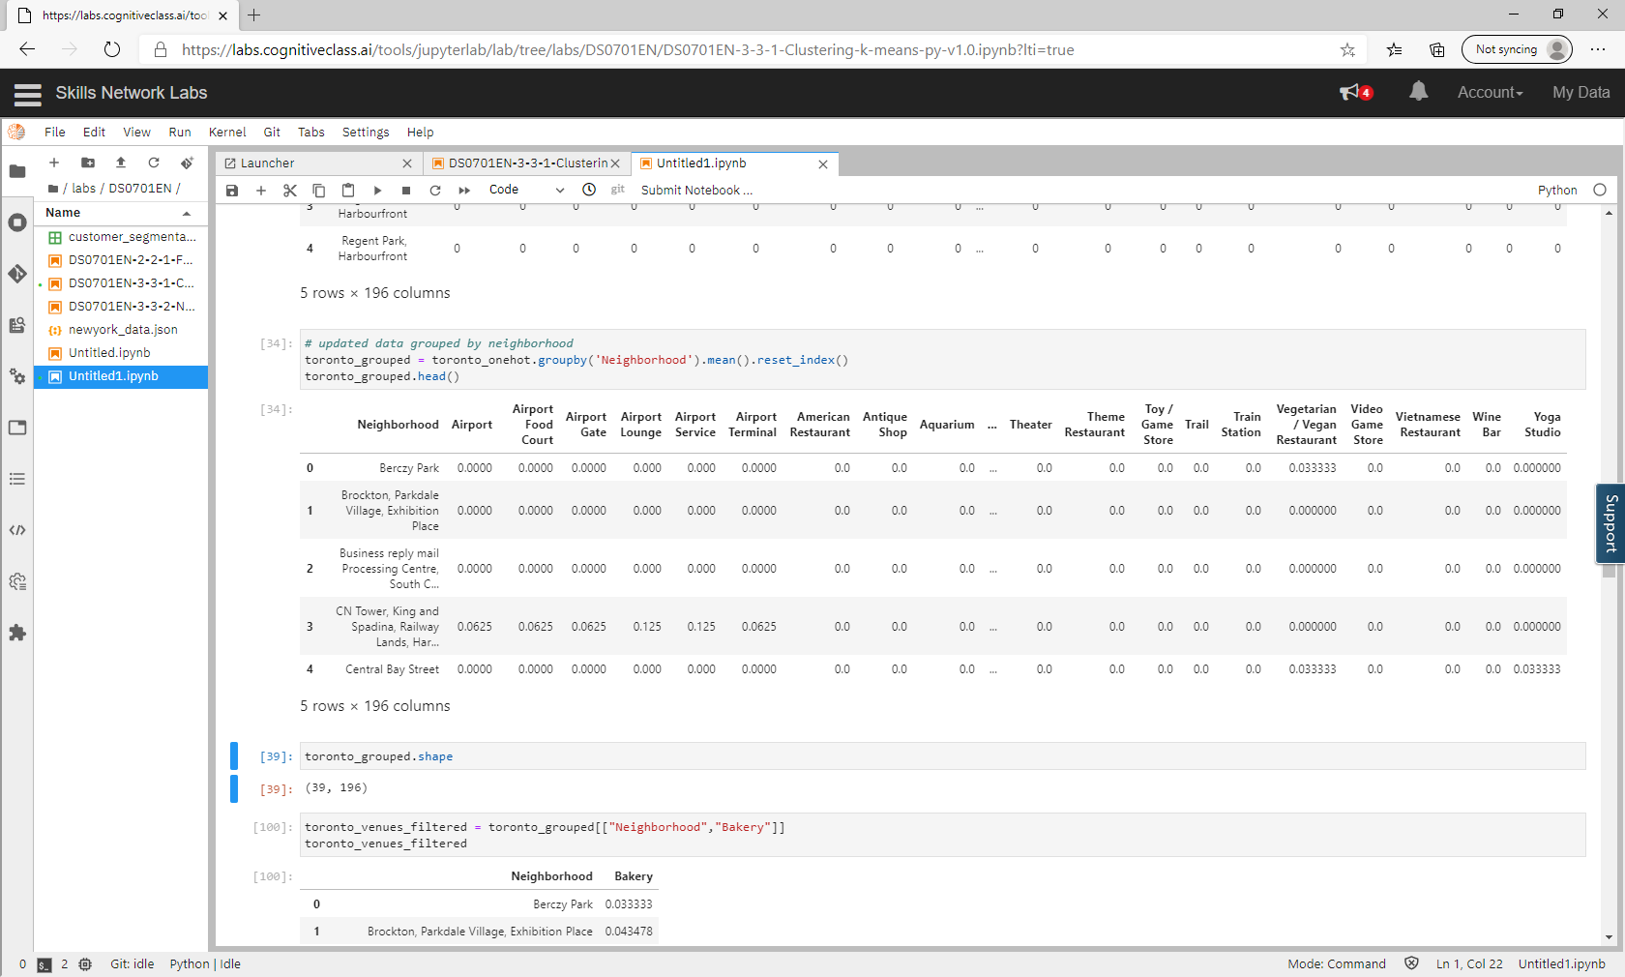

Since we are only interested in Bakeries, the dataset was filtered to only show that venue. A sample of the data is shown below:

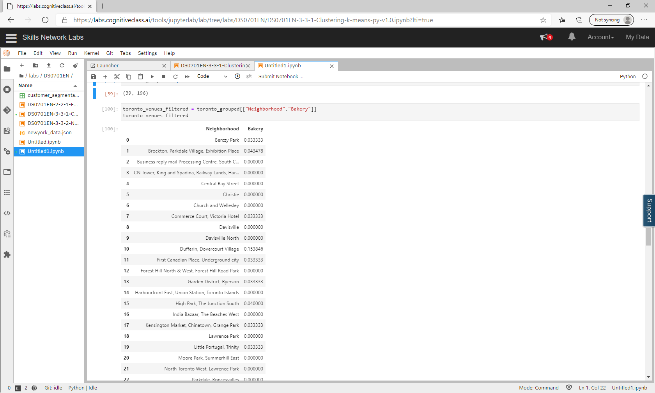

K-Means clustering was performed on the data in order to group the neighborhoods into similar clusters so as to easily identify where there are the least existences of bakeries. Before this can be done though, we need to identify the optimal number of clusters for the data using the elbow method.

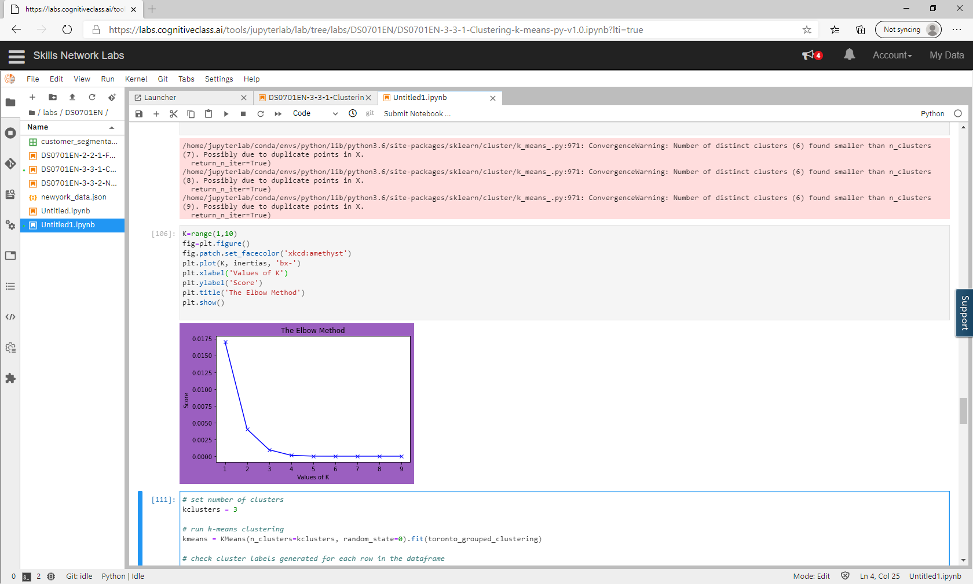

Using the elbow method, the optimal number of clusters is 3.

K-Means clustering was then performed on the data and clusters were assigned to each venue.

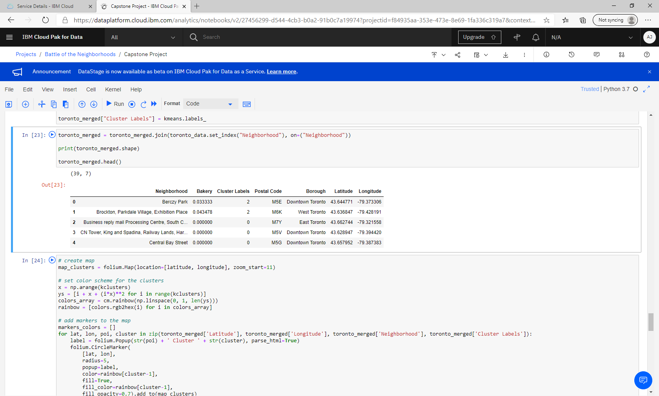

This data was then mapped using Folium where:

* Cluster 0 = Red
* Cluster 1 = Purple
* Cluster 2 = Green

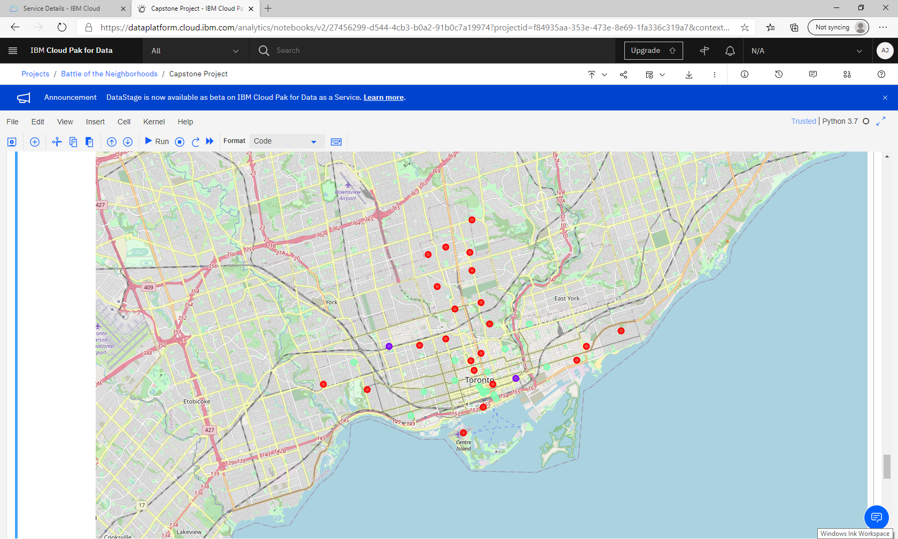

1. **Results**

Based on K-Means clustering, the cluster with the least number of occurrences of a bakery is Cluster 0:

|  |  |  |
| --- | --- | --- |
| **Neighborhood** | **Postal Code** | **Borough** |
| The Beaches | M4E | East Toronto |
| India Bazaar, The Beaches West | M4L | East Toronto |
| Lawrence Park | M4N | Central Toronto |
| Davisville North | M4P | Central Toronto |
| North Toronto West, Lawrence Park | M4R | Central Toronto |
| Davisville | M4S | Central Toronto |
| Moore Park, Summerhill East | M4T | Central Toronto |
| Summerhill West, Rathnelly, South Hill, Forest Hill SE, Deer Park | M4V | Central Toronto |
| Rosedale | M4W | Downtown Toronto |
| Church and Wellesley | M4Y | Downtown Toronto |
| St. James Town | M5C | Downtown Toronto |
| Central Bay Street | M5G | Downtown Toronto |
| Harbourfront East, Union Station, Toronto Islands | M5J | Downtown Toronto |
| Roselawn | M5N | Central Toronto |
| Forest Hill North & West, Forest Hill Road Park | M5P | Central Toronto |
| The Annex, North Midtown, Yorkville | M5R | Central Toronto |
| CN Tower, King and Spadina, Railway Lands, Harbourfront West, Bathurst Quay, South Niagara, Island airport | M5V | Downtown Toronto |
| Christie | M6G | Downtown Toronto |
| Parkdale, Roncesvalles | M6R | West Toronto |
| Runnymede, Swansea | M6S | West Toronto |
| Queen's Park, Ontario Provincial Government | M7A | Downtown Toronto |
| Business reply mail Processing Centre, South Central Letter Processing Plant Toronto | M7Y | East Toronto |

The cluster with the next least number of occurrences of a bakery is Cluster 2:

|  |  |  |
| --- | --- | --- |
| **Neighborhood** | **Postal Code** | **Borough** |
| The Danforth West, Riverdale | M4K | East Toronto |
| Studio District | M4M | East Toronto |
| St. James Town, Cabbagetown | M4X | Downtown Toronto |
| Garden District, Ryerson | M5B | Downtown Toronto |
| Berczy Park | M5E | Downtown Toronto |
| Richmond, Adelaide, King | M5H | Downtown Toronto |
| Toronto Dominion Centre, Design Exchange | M5K | Downtown Toronto |
| Commerce Court, Victoria Hotel | M5L | Downtown Toronto |
| University of Toronto, Harbord | M5S | Downtown Toronto |
| Kensington Market, Chinatown, Grange Park | M5T | Downtown Toronto |
| Stn A PO Boxes | M5W | Downtown Toronto |
| First Canadian Place, Underground city | M5X | Downtown Toronto |
| Little Portugal, Trinity | M6J | West Toronto |
| Brockton, Parkdale Village, Exhibition Place | M6K | West Toronto |
| High Park, The Junction South | M6P | West Toronto |

The cluster with the greatest number of occurrences of a bakery is Cluster 1:

|  |  |  |
| --- | --- | --- |
| **Neighborhood** | **Postal Code** | **Borough** |
| Regent Park, Harbourfront | M5A | Downtown Toronto |
| Dufferin, Dovercourt Village | M6H | West Toronto |

1. **Observations and Recommendations**

Observing the cluster map and the list of Boroughs above, there appears to be a focus of bakeries in the Downtown Toronto Borough, while the Central Toronto Borough there seems to be a deficit. This could be due to the fact Central Toronto appears to have more suburban boroughs (per Wikipedia).

Based on the data and observations, the recommendation is to look at the locations in Cluster 0 with emphasis on the Downton Toronto Borough – such as Christie, Central Bay Street, Rosedale or Queen's Park. This is due to location in Downtown and their lack of any bakery in that particular neighborhood. It is not recommended to look at locations in Cluster 1 as they have the greatest occurrence of bakeries and result in greater competition. Cluster 2 can be considered; however, the new bakery will have to contend with previously established businesses and that may already have a solid customer base.

1. **Conclusion**

In this study, I analyzed the boroughs and neighborhoods of Toronto, Canada to determine the optimal location to open a bakery. K-Means clustering, in tandem with the elbow method, was used to cluster the neighborhoods into similar groups so as to easily identify favorable locations to consider or avoid. These same models can be used to evaluate other business besides bakeries, such as gyms, retail, restaurants, etc.